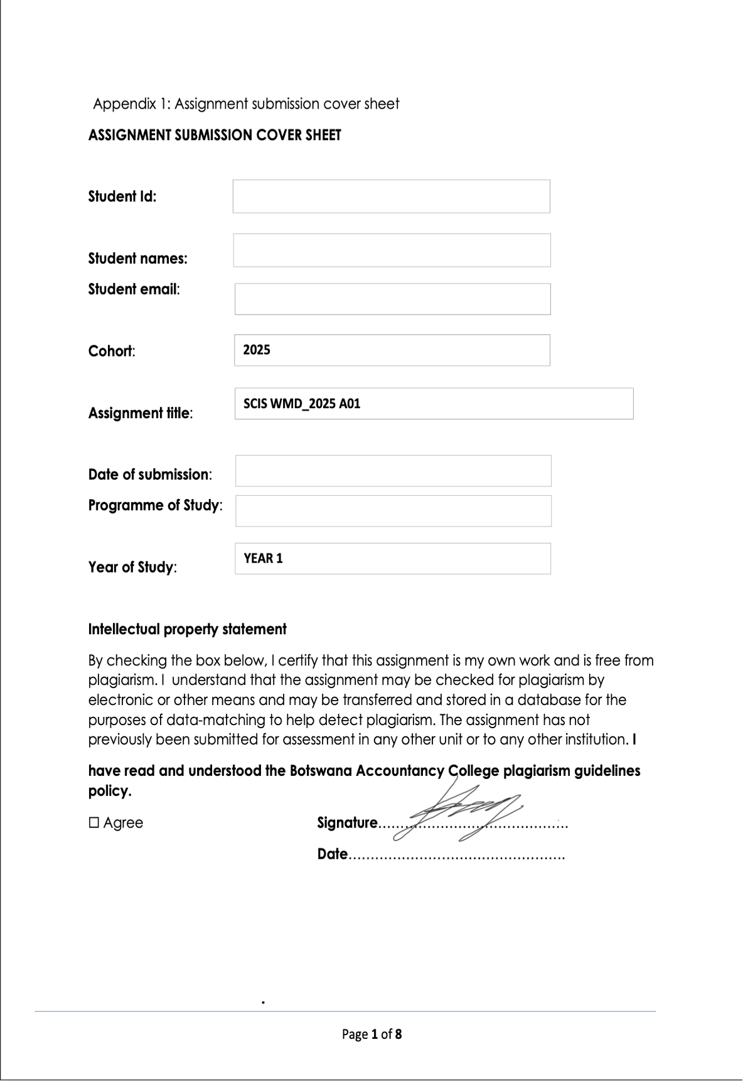



19/09/25

Year 2

CSE

OOAD Assignment Part A

19/09/2025

cse24-107@thuto.bac.ac.bw

Katlego Renee Baitirile

cse24-107

**Requirements Elicitation**

**Functional Requirements**

* Following a consultation with the client, the core functional requirements of the banking system have been defined. The system must serve as a tool for bank tellers to manage customer accounts securely and efficiently. The key functions are:
* The system must allow a teller to open an account for a Customer, who can be either an Individual or a Company/Organization.
* The system must enforce distinct business rules for each account type:
* **Savings Account**: Must not allow any withdrawals. The user interface must not present a withdrawal option for this account type.
* **Investment Account**: Must require a minimum initial deposit of BWP 500.00. The system must prevent the account creation if this minimum is not met.
* **Cheque Account**: Requires the customer's company name (as proof of employment for individuals).
* The system must maintain a transaction history for each account, recording at minimum the date, transaction type (deposit/withdrawal), amount, and the resulting balance.
* The system must allow a single customer to have multiple accounts (e.g., one Savings and one Investment account).

**Non-Functional Requirements**

* The client emphasized that the primary quality attributes of the system should be usability and logical design, in line with the module's focus on Object-Oriented principles.
* **Usability:** The user interface must be intuitive and user-friendly, with a logical layout of buttons and controls to ensure tellers can perform tasks efficiently.
* **Security**: Basic security will be implemented through user authentication using a username and password for system access. Advanced security measures like data encryption are out of scope for this project.
* **Performance:** Given the expected minimal dataset (approximately 10 records for demonstration), performance is not a primary concern beyond ensuring the application runs without unnecessary delay.

**Appendix A: Requirements Elicitation Interview Record**

1. **Interview Metadata**

* Date: 17/09/2025
* Attendees:
  + Interviewer (Systems Analyst): Katlego Renee Baitirile
  + Client (Stakeholder): Kentsenao Baseki, representing Bank Management
* Purpose of Meeting: To elicit and clarify the functional and non-functional requirements for the proposed Banking System, with a focus on OOAD principles.

1. **Executive Summary**

The meeting clarified that the project's scope is narrowly focused on demonstrating core Object-Oriented Analysis and Design principles. The client confirmed the functional requirements from the assignment brief and provided specific details on business rules. For non-functional requirements, the client explicitly narrowed the focus to usability and basic authentication, stating that advanced concerns like encryption, high-performance benchmarks, and data backups are out of scope for this module.

1. **Clarified Functional Requirements**

* The term "register" is less appropriate; the core function is to "open an account for a customer."
* A customer can be an Individual or a Company. The system must capture different data for each (e.g., source of income for an individual vs. business forecasts for a company).
* Savings Account: The UI must completely hide the withdrawal option.
* Investment Account: The system must absolutely prevent account creation if the initial deposit is less than BWP 500.00.
* Cheque Account: Requiring the company name is sufficient for proof of employment.
* A single customer can have multiple accounts (as stated in the original brief).
* Transaction history must show: date, transaction type, amount, and resulting balance.

1. Clarified Non-Functional Requirements

* Security: Username and password authentication is sufficient. Data encryption is not required.
* Usability: This is a key focus. The UI must be logical and easy to use.
* Performance: Not a critical concern due to the small scale of the demonstration system.
* Reliability/Backups: Concepts like system uptime and data backups are explicitly out of scope.

1. **Key Takeaways and Scope Limitations**

The client reiterated that the assignment's primary goal is to understand and apply OOP concepts (abstraction, inheritance, polymorphism, etc.) and not to build a fully production-ready system. Therefore, requirements related to advanced security, database normalization, and system administration are excluded from this project's scope.

1. **Attendee Sign-off**

The above document accurately reflects the requirements discussed during the interview.

Katlego Baitirile, Kentsenao Baseki  
Systems Analyst, Client

Date: ___17/09/2025____

**Structural UML Diagram**

**Use Case**

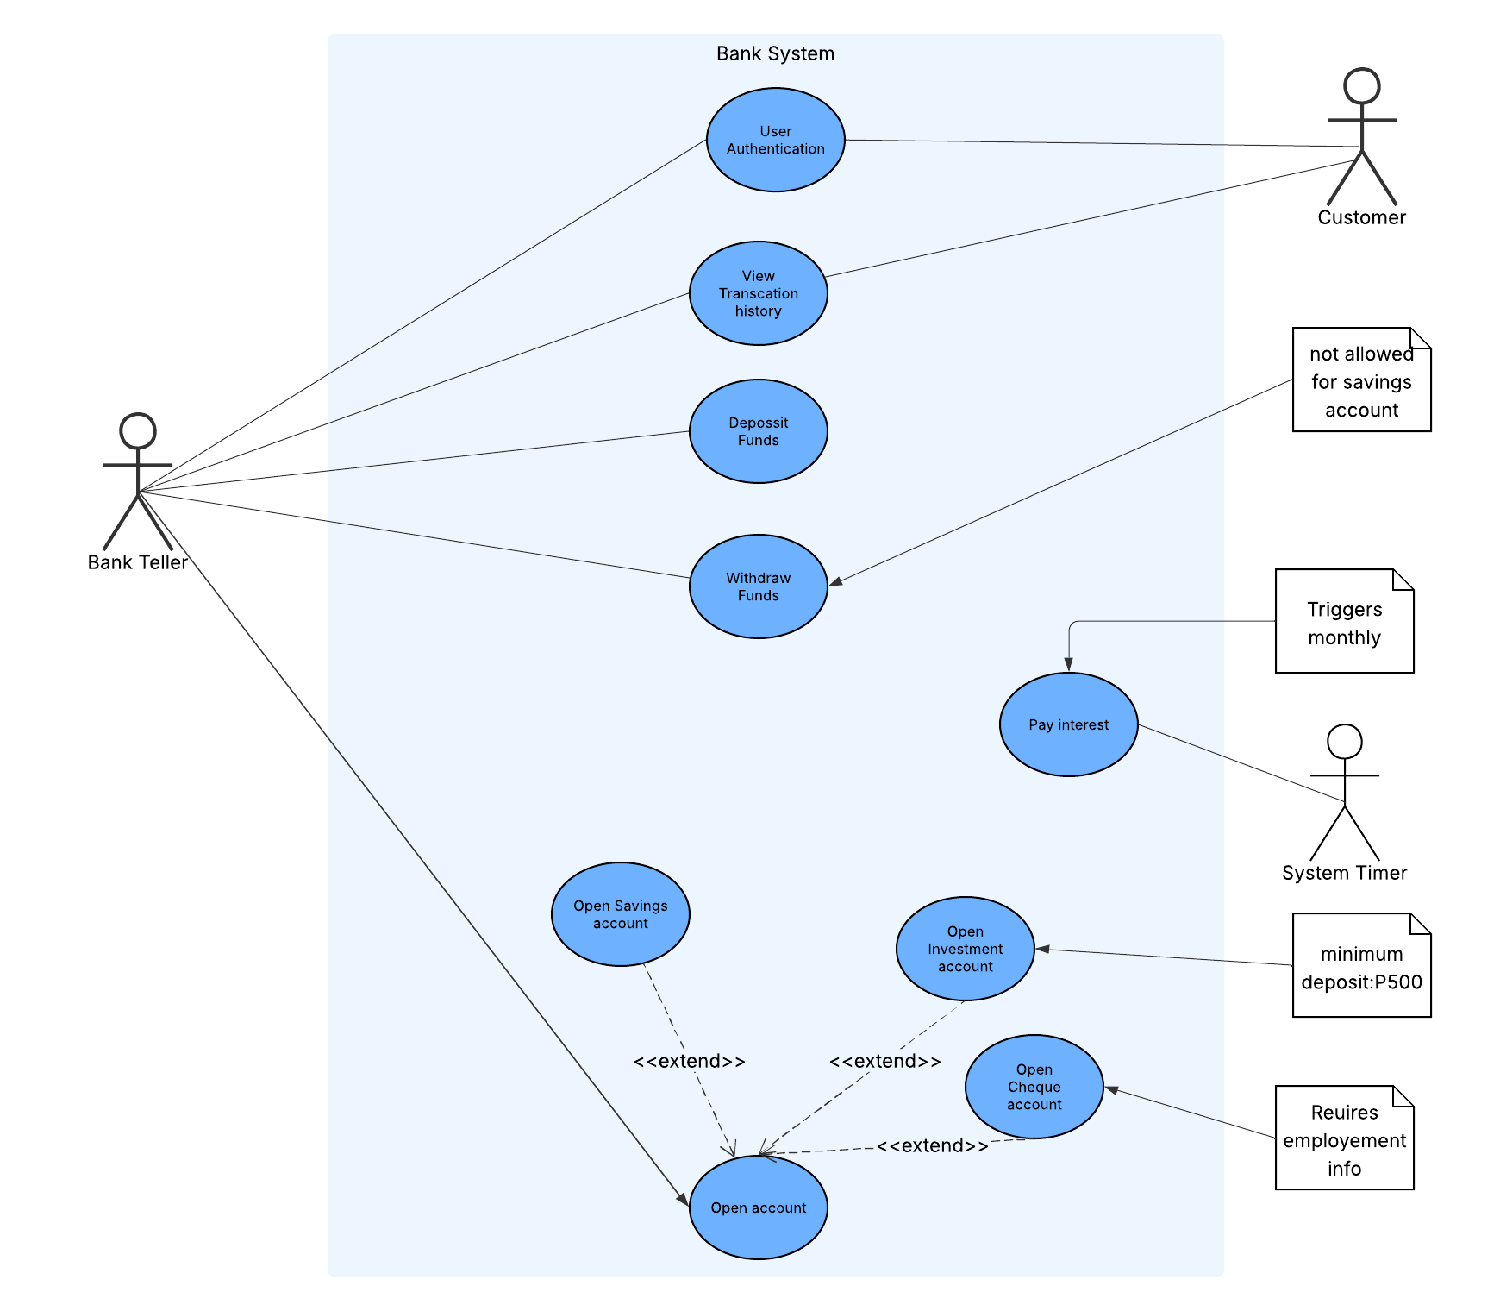

Class Diagram

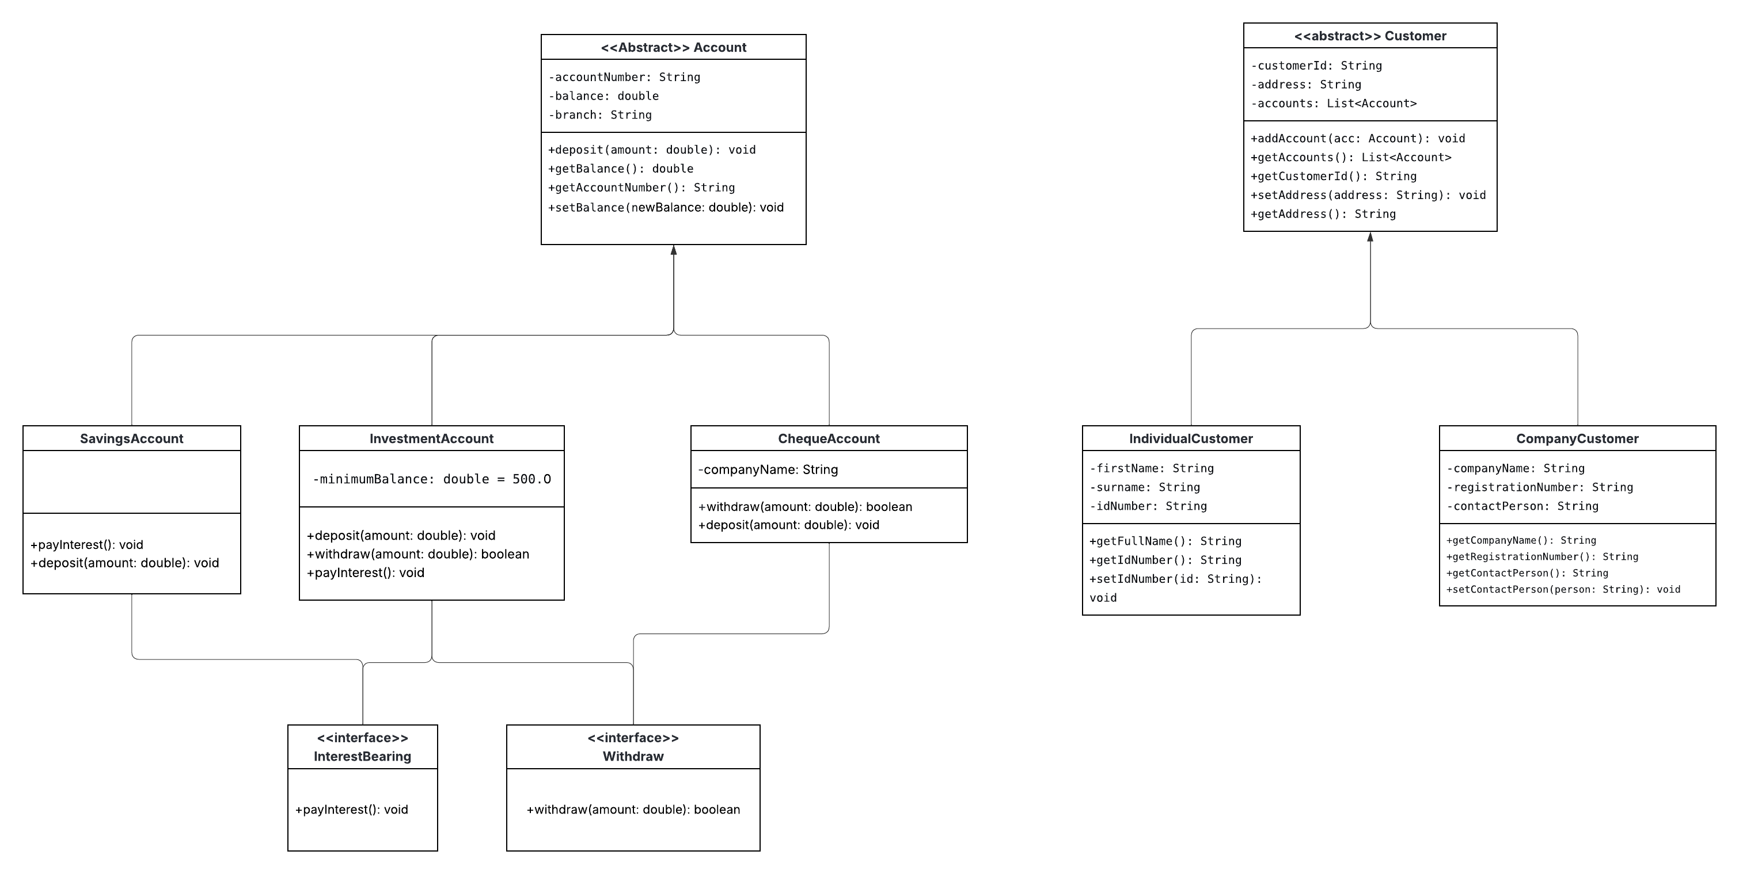

**Behavioral Diagram**

**Sequence Diagram**

**User Authentication Sequence Diagram**

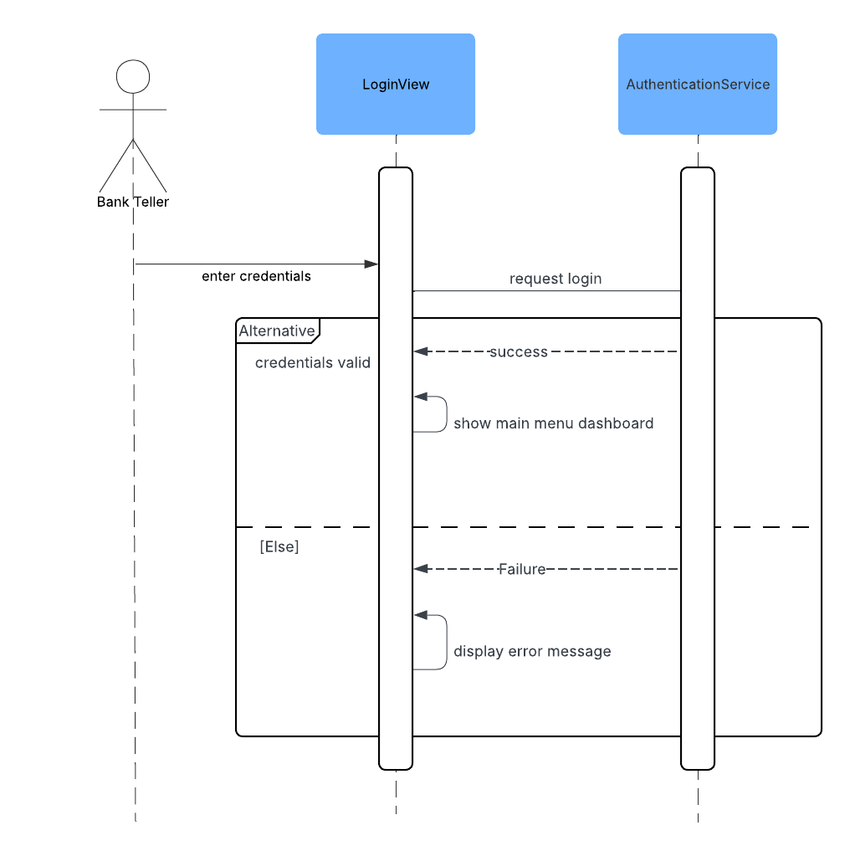

**Deposit Sequence Diagram**

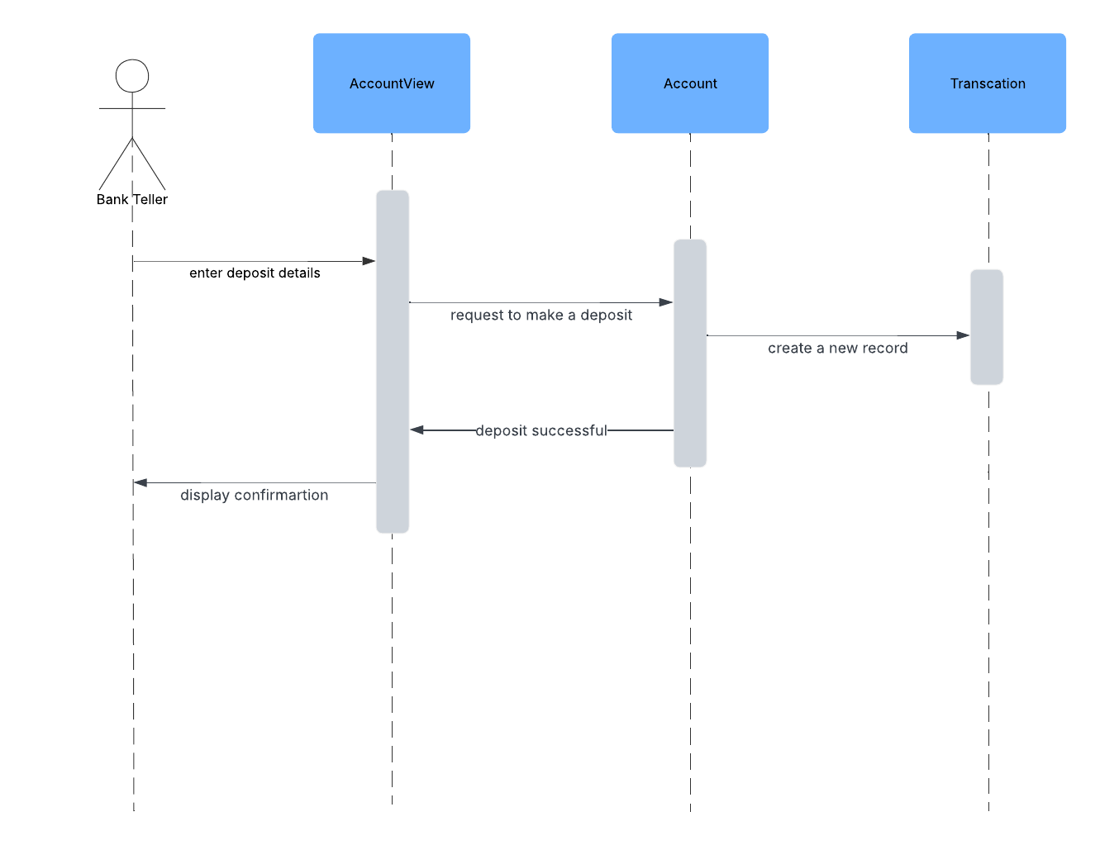

**State Diagram**

